


SAVEETHA SCHOOL OF ENGINEERING

SAVEETHA INSTITUTE OF MEDICAL AND TECHNICAL SCIENCES

COMPUTER SCIENCE AND ENGINEERING PROGRAMME

LAB MANUAL CSA1305

THEORY OF COMPUTATION

COMPUTER SCIENCE AND ENGINEERING PROGRAMME

LIST OF EXPERIMENTS

2.Write a C program to simulate a Non-Deterministic Finite Automata (NFA) for the given language representing strings that start with o and end with 1

AIM:
To write a C program to simulate a Non-Deterministic Finite Automata (NFA) that accepts binary strings which start with 0 and end with 1

Apparatus Required
- Computer/Laptop
- GCC Compiler (Turbo C/GCC/CodeBlocks/VS Code)
- C Programming Language

Algorithm
- Start the program.
- Read the input string.
- Find the length of the string.
- Check whether the first character is a.
- Check whether the last character is a.
- Verify that all characters are either a or b.
- If all conditions are satisfied, display Accepted
- Otherwise, display Rejected .
- Stop the program.

Program Code
#include <stdio.h>
#include <string.h>

int main()
{
char str[100];
int len;

printf("Enter a binary string: ");
scanf("%s", str);

len = strlen(str);

if(len > 0 && str[0] == '0' && str[len - 1] == '1')
printf("String Accepted by the NFA.\n");
else
printf("String Rejected by the NFA.\n");

return 0;
}

Sample Input 1
Enter a binary string: 01101

Sample Output 1
String Accepted by the NFA.

OUTPUT: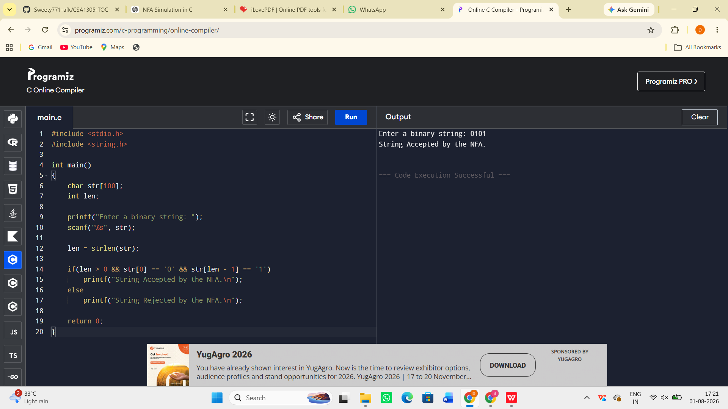

Result:
The C program to simulate a Non-Deterministic Finite Automata (NFA) for binary strings that start with 0 and end with 1 was successfully implemented and executed. The program correctly accepts valid strings and rejects invalid strings.

